Lab 08

From the given circuit,

5t = 5\*R\*C = 4.85ms

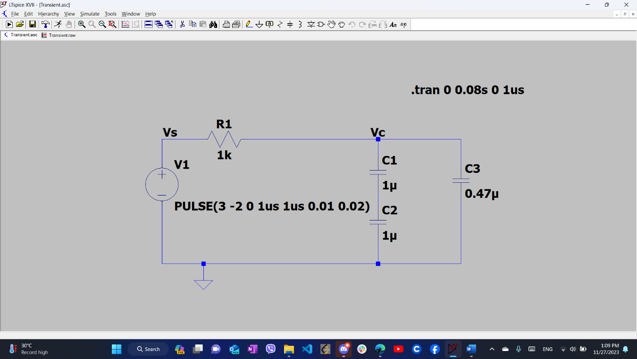

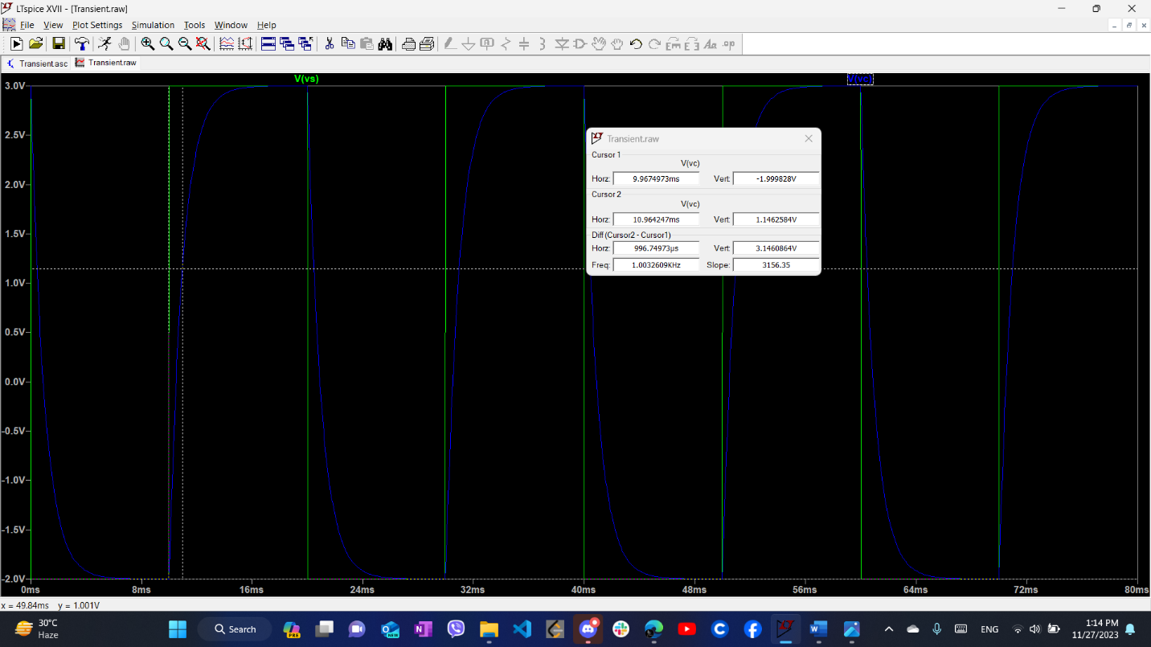

t = 996.749us

5t = 4.983ms

Lab 09

For 1kHz

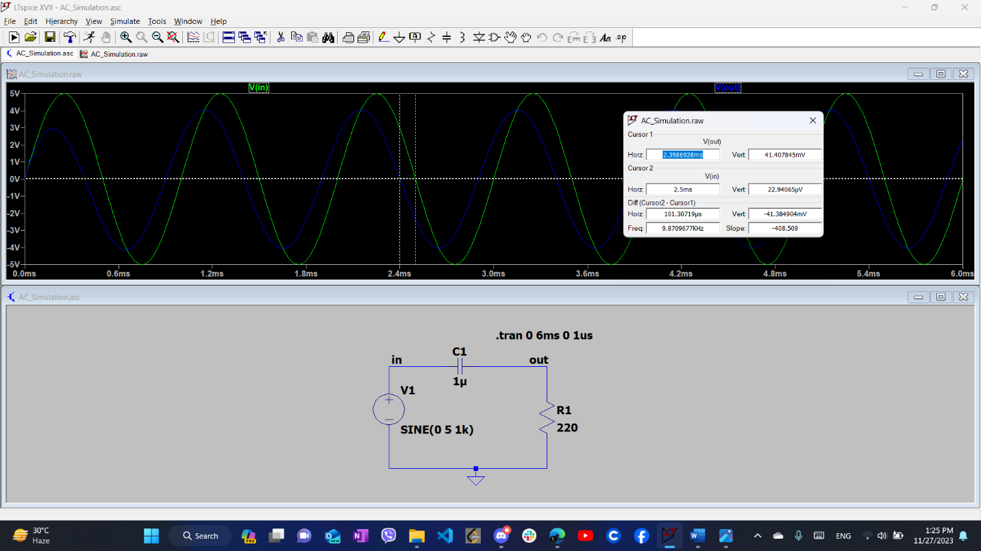

Phase Difference = 36.47052 degree

For 2k Hz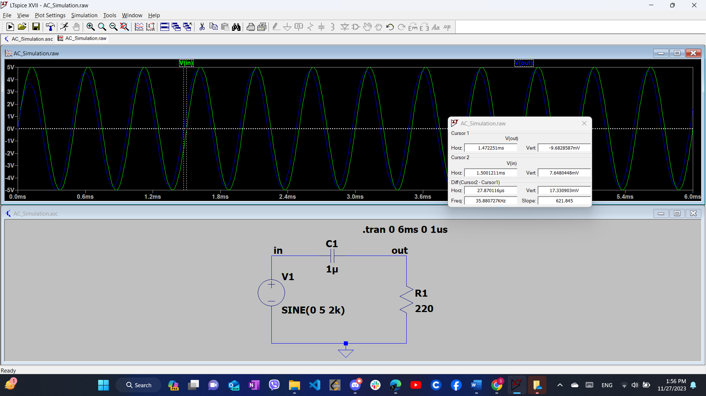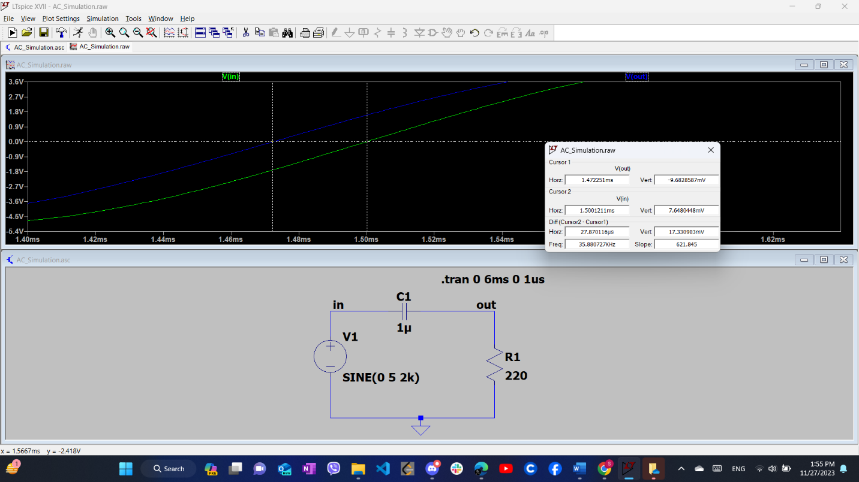

Phase Difference = 20.06648 degree

For 500 Hz

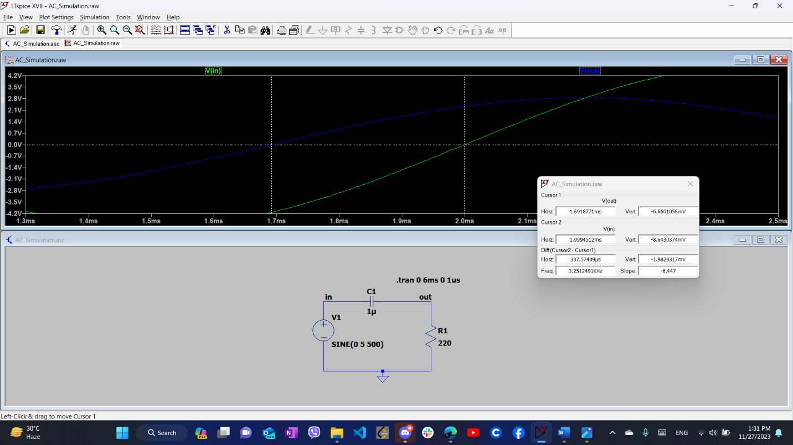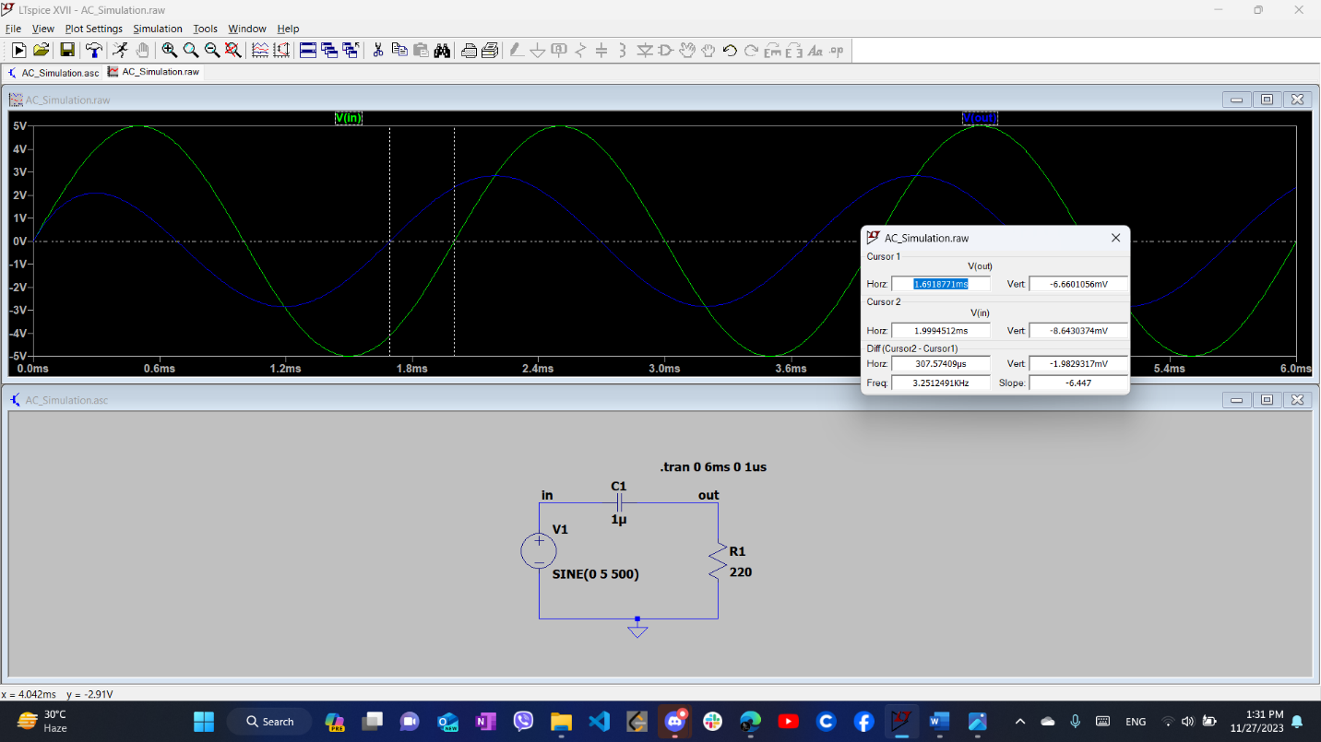

Phase Difference = 55.3633 degree